# Explanation of the website’s code snippets

Login on Webpage

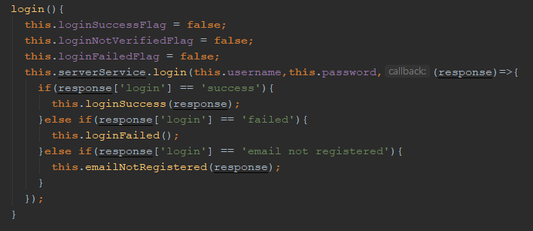

Login on service connecting with web service

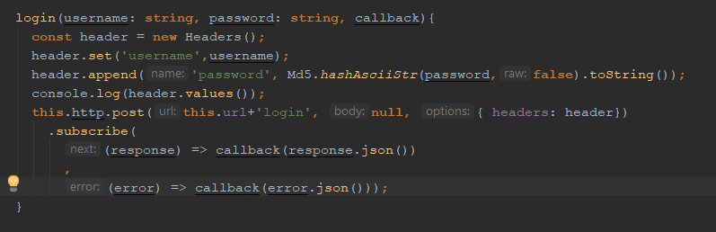

The username and password fields are extracted from their input fields and their data saved in instance variables. After the user clicks on the login button, the login method is executed. The login method sends this data to the server where the password field is hashed using the MD5 hashing algorithm. This data is then sent to the web service. The service checks if the hash and username is associated with each other and then responds with one of three possibilities. The login can be either successful or fail, on success the user is sent into the website and on fail a dialog appears saying that the wrong combination was entered. The third response only happens when the user’s email has never been verified, the user is then prompted to verify or resend the verification email.

Uploading Album

The process of uploading a file consists of a few steps that have to be performed in the right order.

Step one.

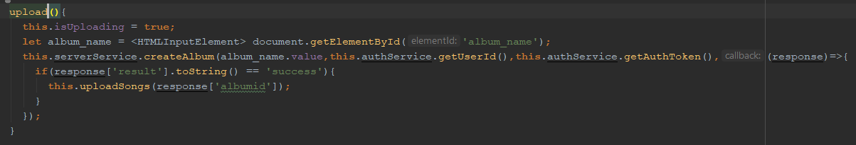

Step two followed by step three.

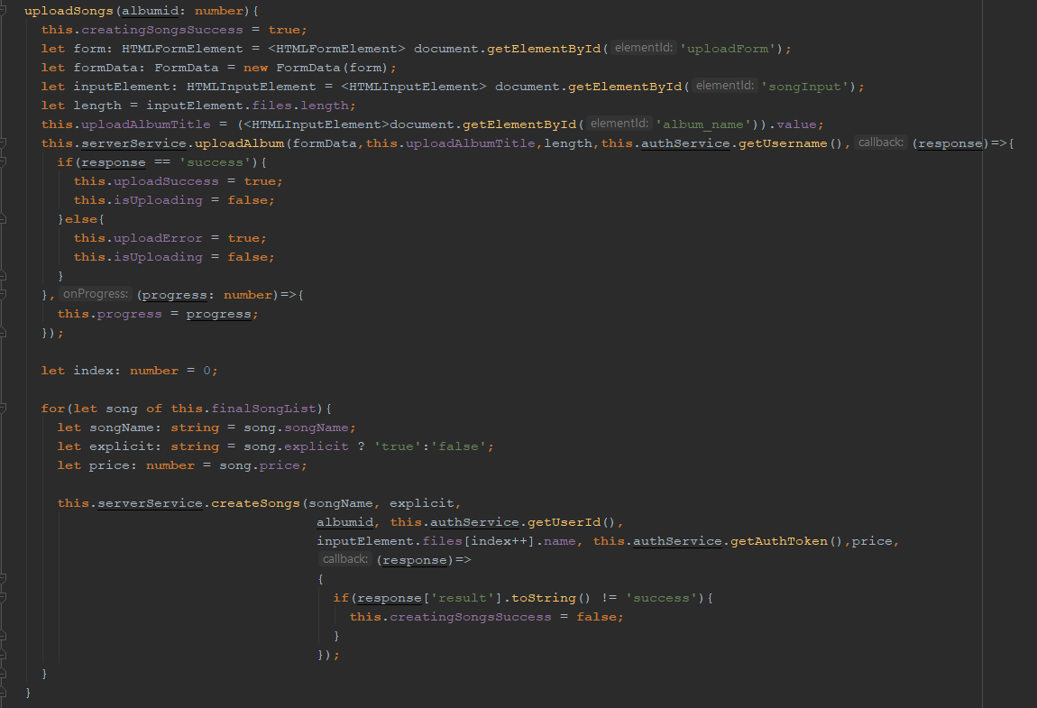

The steps are as follow:

1. Create album in database and return the primary key
2. Use the primary key of the album to upload the raw mp3 files into the server’s file system.
3. Add the actual names and cost of each song and verify it to ensure there’s no room for human error.

The raw mp3 files are then saved in the file systems and their path is stored in the database for later retrieval. The song names specified by the user are also saved in the database and linked to the each respective file path. At this point the album is not released yet. The user has to explicitly release the album to ensure no albums get published by accident. This is done by entering manage content mode and clicking the release button that will be present on all albums that have not yet been released.

Music Footer

The music footer is present on all pages except the login, register and landing page. This component is one of the core components in the web application due to its ability to stay in place and keep all data as the user navigates through the website. When a user clicks on a song located inside an album, the album is automatically added to the music footer’s playlist and the user can forward and rewind through the playlist. The user can also seek through the current song using the progress bar located at the top of the music footer. The music footer also does not allow you to play a song that you do not own for longer than a 30-second preview period.

It also contains the information regarding the current track and controls the volume at which the music is being outputted by the speakers.

Functionality of the seek bar

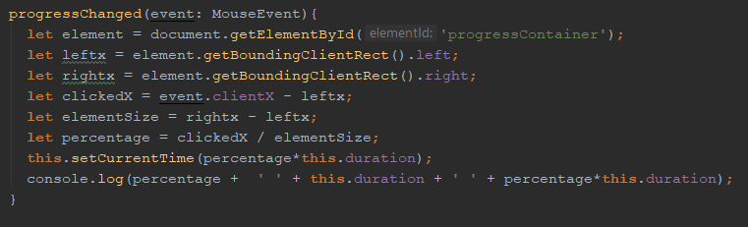

Functionality of the preview player

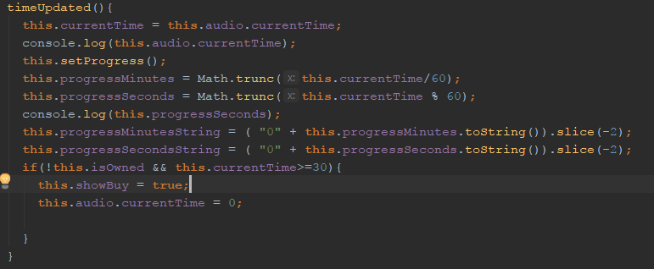

Functionality of the volume controller

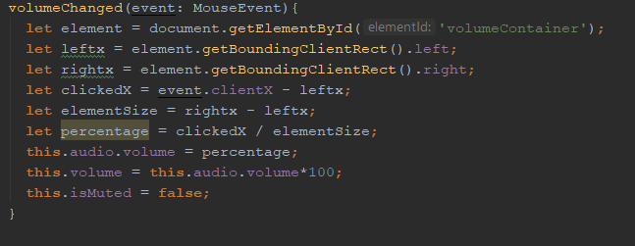

Wallet Component

The wallet component handles all transactions and shows the user his/her balance. The balance is shown as an amount of coins as well as the amount of songs the user can buy with the current balance. Since the currency’s buying power varies a lot, the amount of songs the user can buy is a much better indicator of how much the user actually has than the amount of coins. The wallet also shows the average cost of a song and the average cost of an album.

A small version of the wallet also runs in the website’s navigation bar to ensure that the user always knows his/her balance. It is indicated with a number and a logo containing an orange coin and a soul ghost inside of it.

Functionality of Wallet component

